PIA page #4, 4. Program or activity description
Is this a fact?
Moreover, for compliance and auditing purposes, all chat interactions are securely saved in a PostgreSQL database. This chat history can be used for audit purposes and is currently retained for a period of 90 days. If the system's content filter, monitored by Microsoft via their v2 content filter, is triggered, we can review the messages at that time. While there is currently no access to the PostgreSQL database for this purpose, it remains intact for audits or investigations if required.

Should we mention future enhancements? Should we add Agents?
EVA is designed to augment and support ESDC employees in their work, enhancing productivity without replacing the essential human elements of workplace culture and ethics. The virtual assistant will offer a comprehensive suite of language services, including advanced text analysis, language detection, text translation, speech-to-text and text-to-speech conversion, and computer vision capabilities for image analysis and interpretation. Support for both official languages, English and French, is integral to EVA’s functionality

Azure AI Foundry is not approved by ESDC yet (Niasha knows more about it)
EVA is a new initiative and does not have any dependencies on existing data or systems. EVA Chat is hosted on Microsoft Azure utilizing Azure OpenAI Service and Azure AI Foundry which allows to customize the safety and security of the application.

I have no knowledge on this.
Content will be annotated by category and blocked according to a set threshold determined by IT security. A slider can be adjusted for violence, hate, sexual, and self-harm categories, to be set at a ‘high’, ‘medium’, and/or ‘low’. The Azure service will generate alerts and send emails to designated groups in charge of chat history. (Please see Annex G fig. 1 for a sample daily prompt progress alert metrics, fig. 2 for a sample blocked prompt error message from EVA Chat and fig. 3 for a sample alert generated by a blocked prompt).

EVA Chat has two distinct collection/usages of personal information:

- Input data: data, which may include personal information, which a user inputs into the tool in order to generate a response or output. Input data, as well as the accompanying output, is stored in (Microsoft Azure) logs, accessible only by the Automated Infrastructure Team. This information is considered transitory, kept only for 90 days, and not organized in a way so as to be easily retrievable. Input data is not meant to replace primary program collection or storage of personal information, but is meant to facilitate user interaction with the tool.

2. User data: limited personal information collected about users (ESDC employees) for the function of the tool

Page #5, 6. Requirement for a PIA
Confuse statement
Although EVA Chat does not fall under the Directive on Automated Decision-Making, and administrative decisions are not directly implicated in EVA Chat’s functions or Azure AI Foundry| Azure OpenAI Service’s content filtering/monitoring, the use of personal information in EVA Chat, including storage in the logs, is a substantial modification to the handling of personal information. EVA Chat could also represent a substantial modification to the handling of personal information for many ESDC programs. The potential for employees to misuse the tool to assist with or make administrative decisions using personal information in EVA Chat was identified as a potential risk to privacy.

Page #7, 3. If the social insurance number (SIN) is collected:
Is this related to the Rina/Sally’s decision
EVA may collect SIN incidentally as part of input data to support work-related employee tasks. Feasibility analysis is underway to additionally assess options to mask potential SINs before log storage. If adopted, masking would occur at ingestion, preventing cleartext persistence in the PostgreSQL database. Individual users and programs are responsible for ensuring that SIN entered into EVA Chat is entered and used in accordance with prescribed guidelines and legal requirements for that program.

Page#8, 2.Does a PIB needs to be substantially modified or edited for this program?
I recall that Rachel was doing some investigation with TBS on this
Therefore, a class of personal information will be established and registered in Info Source for the use of personal information in EVA Chat and similar tools used in the department.

Page #9, 4. Handling of personal information
@Thaya Some places say the log stay for 90 days, some place says only 90 days… and here 90 days is the minimum

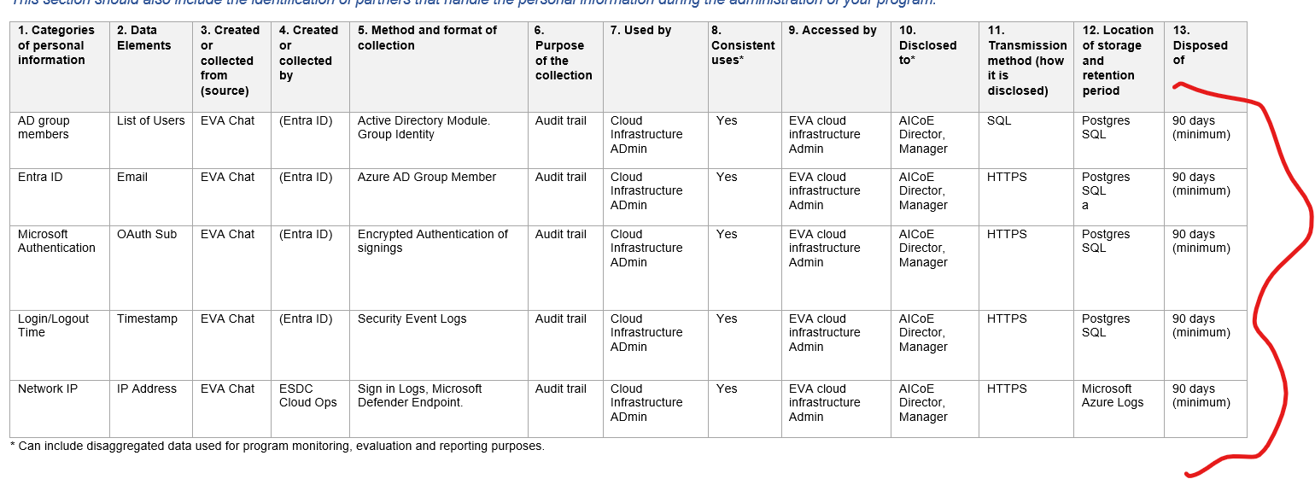

Page #10, 5. Process flow description
Will it have audit?
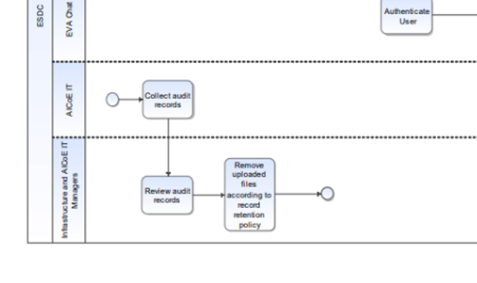
Please confirm data retention
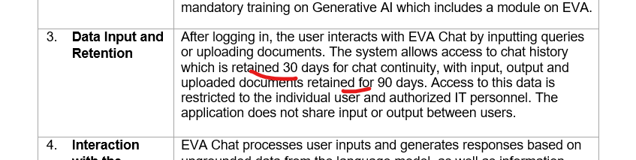

Please confirm Quarterly reviews
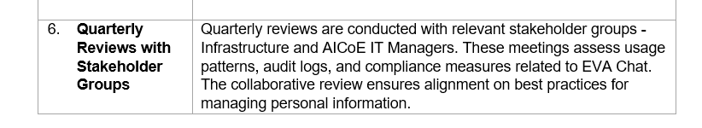

Page #15, Section C.1 – Privacy Principles, 1. Accountability, question #6
Will the institution be provided with the results of regularly scheduled audits and compliance checks on the privacy requirements of all involved parties?
NO
It should say “YES” .. but it also depends on Rina/Sally’s decision
…
In line with the Office of the Privacy Commissioner’s 2023 principles for responsible, trustworthy and privacy-protective generative AI technologies, ESDC acknowledges that traceability and explainability are essential components of responsible AI deployment.
As such, IITB should take appropriate steps to ensure that outputs from EVA Chat are either traceable and explainable or, where explainability is not technically feasible, explicitly disclose that limitation to users and program authorities. This ensures transparency, aligns with privacy best practices, and upholds the integrity of administrative decision-making processes supported by AI tools.
…
Since AI is rapidly evolving, it is imperative that changes or updates to EVA Chat are monitored, and new or renewed privacy assessments conducted when required. In addition to establishing a process for monitoring the use of personal information in EVA Chat, a reporting process to update PMD regularly of any changes to EVA Chat or it’s environment should be established for the life of the tool.

Page #26, 3. Limiting use
Has the requirement been recorded in AICOE ADO?
Q#1 Will personal information entered into the system be used exclusively for the reason(s) it was collected?
Personal information as part of input data is collected in logs by EVA. It is the responsibility of users and their respective program authorities to ensure that personal information in chat input and output will be used exclusively for the purposes it was collected, including consideration of whether use of generative AI is appropriate.
However, there is no current method, such as auditing or monitoring of collection and use of personal information, which can determine if personal information, captured incidentally as part of employees’ use of the tool, is being used for the reason it was collected. Please see the answer to section 1, question 6 regarding this risk.
Although not explicitly a risk or issue, PMD advises IITB to adjust the wording of the notice to users under the chat input box to read “EVA Chat, like all LLMs, can make mistakes. There are risks associated with relying on output from EVA Chat. Verify important information. Do not use EVA Chat to make or support administrative decisions involving individuals.”

Page #52, 2. Do you have a terms of use to notify users of their responsibilities regarding the handling and use personal information?
Has the requirement been recorded in AICOE ADO?
No privacy risk or compliance issue identified.
PMD reminds IITB to inform them as the ToU or other communication materials are updated.

Page #56, 6. Is there a clearly defined and easy process for individuals to communicate with the appropriate individuals regarding the handling of their personal information?
Has the requirement been recorded in AICOE ADO?
As per the OPC’s Principles for responsible, trustworthy and privacy-protective generative AI technologies “All parties should:…Inform individuals what, how, when, and why personal information is collected, used or disclosed throughout any stage of the generative AI system’s lifecycle (including development, training and operation) for which the party is responsible.”
As AI, and generative AI in particular, is a newer technology which is being integrated into ESDC services and operations, Canadians may have questions about where, how and for what purpose their personal information is being used, handled and stored with AI, including EVA Chat. PMD advises IITB to work with PASRB on reactive lines to respond to potential queries from Canadians with regards to the handling of personal information in EVA Chat.

Page #61 risk #3
Depends on Rina/Sally’s decision
AI COE will provide branch level statistics on volumes of suspected usage of sensitive information within EVA.

PMD will analyze data provided by IITB through this process to identify trends and potential risks to privacy from the department's use of EVA Chat.

OPI: AICOE ,

Timeline: Q4 FY 2025/2026

Page #77 Risk #4 Current processes for disposal of information, including personal information, held in EVA’s logs are manual and use quarterly Automated Infrastructure Team/AICoE manager meetings as an anchor point for the disposition process
Are the log files deleted automatically when they are 90 days old?
PMD recommends automating disposition processes for EVA’s logs, in order to ensure information stored in the logs is not kept longer than is needed. | To mitigate this risk with manual processes, an automated log deletion process has been implemented with the deployment of EVA Chat version 1.3 in October 2025.  OPI: AICOE (IITB)  Timeline: Q3 FY 2025/2026

